

CC LAB SESSIONAL

• Name :HITU RAJ

• Roll no. :2005025

• Branch :CSE-10

1. Creating a bucket

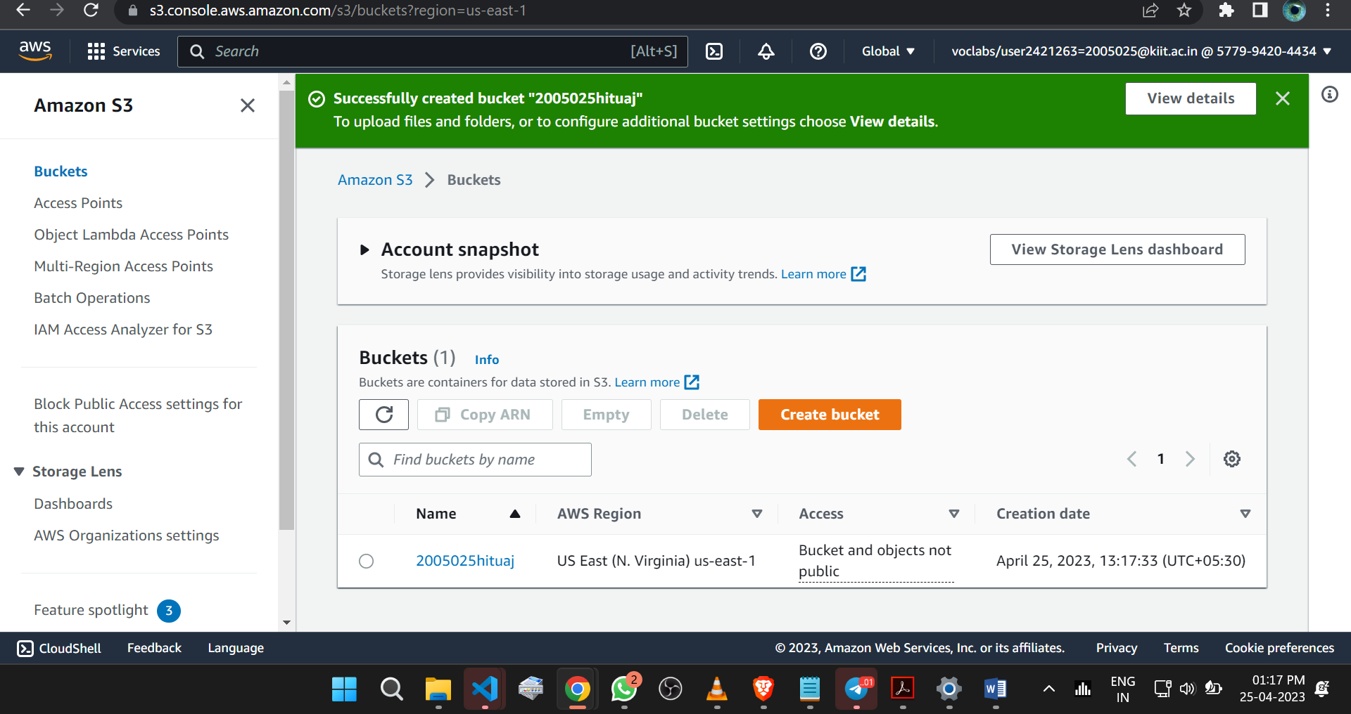

1. Uploading multiple files

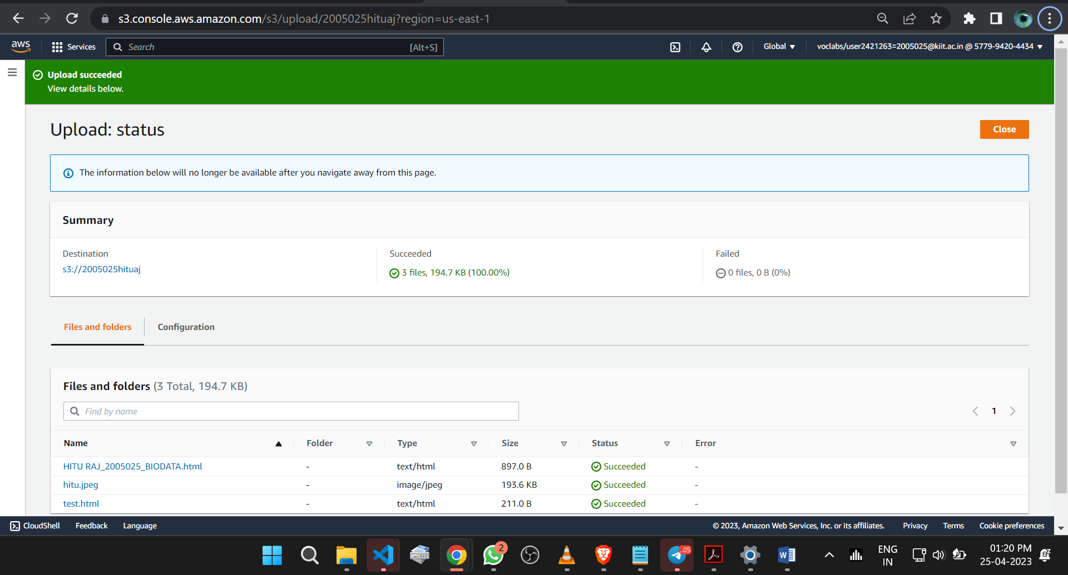

1. Creating a user in S3-support to read a S3 bucket

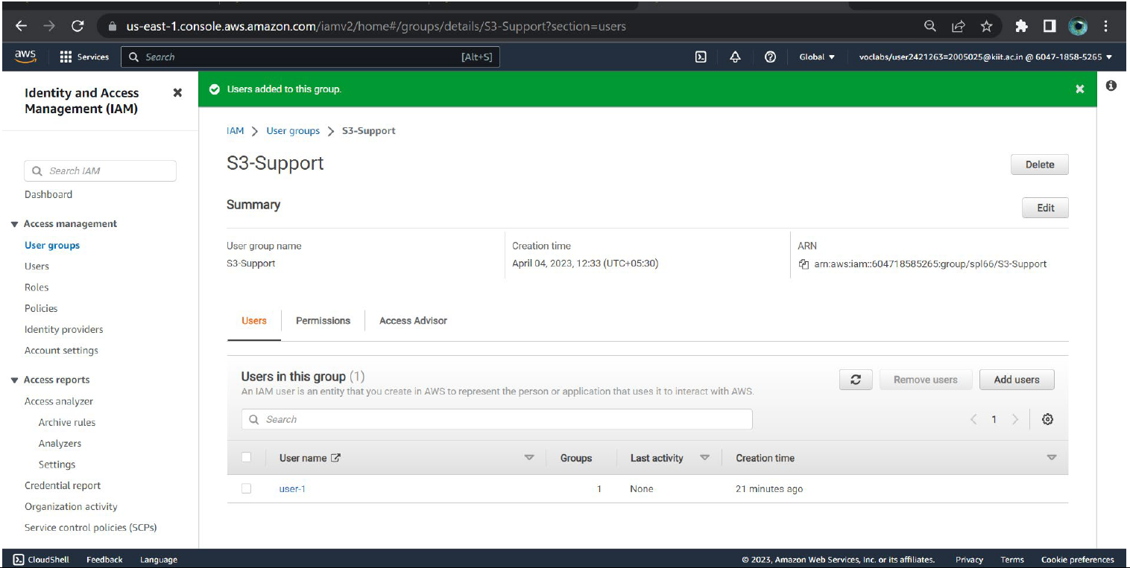

1. S3-support can access the bucket

